LAB2 REPORT
1. Executive Summary & Introduction
This laboratory report details the technical implementation, device hardening, and verification steps performed in Packet Tracer Lab 1.6.2: Configure Basic Router Settings - Physical Mode. Unlike traditional logical mode simulations, this lab was executed entirely within Packet Tracer’s Physical Mode (PTPM). This environment closely mimics a real-world enterprise wiring closet, requiring proper physical equipment mounting in a standard network rack, manual cable management, and precise physical patch-panel to device port patching.
The core focus of this lab is Infrastructure Hardening on a Cisco 4321 Integrated Services Router (ISR) designated as R1. In modern network design, edge routers are highly vulnerable to unauthorized access, brute-force attacks, and data eavesdropping. This lab successfully implements strict local security policies, secure remote management via SSHv2, multi-protocol network interfaces (IPv4/IPv6 Dual-Stack architecture), and structural access controls to establish a highly resilient foundational configuration.
2. Lab Objectives
The primary technical objectives accomplished during this laboratory exercise include:
- Physical Layer Infrastructure Setup: Deploying hardware devices to the rack, configuring physical console cable links for out-of-band management, and interconnecting local area networks via twisted-pair copper straight-through cabling.
- Basic Device Initialization: Setting the standard device identity and stopping unwanted DNS translation delays.
- Device Hardening & Administrative Security: Implementing global password policies, local database user creation with strong cryptographic hashing, and encryption of plaintext configurations.
- Secure Remote Management Realization: Transitioning management access from insecure protocols (Telnet) to Secure Shell version 2 (SSHv2) utilizing asymmetrical RSA encryption keys.
- Brute-Force & Denial of Service (DoS) Mitigation: Applying login block throttling to thwart automated password-guessing scripts.
- Dual-Stack Interface Configuration: Provisioning interfaces with parallel IPv4 and IPv6 logical subnet configurations, along with descriptive markers.
- End-to-End Connectivity Verification: Validating complete internal communication pathing via standard troubleshooting tools (Ping and SSH) to achieve 100% target parameters.
3. Addressing Table
The network topology comprises two distinct local subnets joined by the R1 router, alongside a virtual loopback interface testing environment. The logical network is structured as follows:
Device | Interface | IPv4 Address | Subnet Mask / Prefix | IPv6 Address / Prefix | Default Gateway
R1 | G0/0/0 | 192.168.1.1 | 255.255.255.0 | 2001:db8:acad:1::1 /64 | N/A
 | G0/0/1 | 192.168.2.1 | 255.255.255.0 | 2001:db8:acad:2::1 /64 | N/A
 | Loopback0 | 10.10.10.1 | 255.255.255.255 | 2001:db8:acad:a::1 /64 | N/A
PC-A | NIC | 192.168.1.3 | 255.255.255.0 | 2001:db8:acad:1::3 /64 | 192.168.1.1
Server (PC-B) | NIC | 192.168.2.3 | 255.255.255.0 | 2001:db8:acad:2::3 /64 | 192.168.2.1
4. Technical Implementation & Command Breakdown
The system initialization and configuration were carried out sequentially on the Cisco IOS Command Line Interface (CLI) via the physical console bridge. Below is the comprehensive command architecture utilized, along with an in-depth technical analysis of each module.

4.1. Global Initialization & Identity Mapping
Router> enable
Router# configure terminal
Router(config)# hostname R1
R1(config)# no ip domain-lookup
R1(config)# ip domain-name ccna-lab.com

- Technical Analysis: The hostname R1 command replaces the generic factory label, establishing administrative context. The no ip domain-lookup command is an essential operational tweak; it disables the router from attempting to resolve mistyped CLI execution commands into IP addresses via DNS broadcast, which avoids long, un-interruptible terminal hang times. The ip domain-name command establishes the structural domain suffix requisite for the asymmetric crypto key generation process.

4.2. Password Quality Control & Global Encryption
R1(config)# security passwords min-length 12
R1(config)# enable secret $cisco!PRIV*
R1(config)# service password-encryption
- Technical Analysis: Executing security passwords min-length 12 sets a deterministic length barrier at the software level; any subsequent passwords configured with fewer than 12 characters are automatically rejected by Cisco IOS. The enable secret command applies a one-way cryptographic hash algorithm to safeguard access to Privileged EXEC mode. Running service password-encryption forces the Cisco IOS to automatically convert all current and future clear-text passwords (such as console or VTY passwords) within the configuration file into Type-7 obfuscated text, preventing casual "shoulder-surfing" exposure.

4.3. Secure Shell (SSHv2) & Virtual Terminal Hardening
R1(config)# username SSHadmin secret 55Hadm!n2020
R1(config)# crypto key generate rsa modulus 1024
R1(config)# line vty 0 4
R1(config-line)# transport input ssh
R1(config-line)# login local
R1(config-line)# exec-timeout 4 0
R1(config-line)# exit
- Technical Analysis: To replace insecure Telnet access, a localized user account SSHadmin is provisioned using a robust SHA-256 password hash via the secret parameter. The command crypto key generate rsa modulus 1024 generates a public/private key pair using the RSA algorithm with a key size of 1024 bits. This key length automatically shifts the router’s operational capability to SSH Version 2 (SSHv2). On the virtual terminal lines (line vty 0 4), transport input ssh completely closes down Telnet inbound channels, allowing only encrypted SSH sessions. The login local command directs the line to check credentials against the router's internal security database rather than an unauthenticated link. Finally, exec-timeout 4 0 terminates an idle management session after exactly 4 minutes and 0 seconds, neutralizing the risk of abandoned terminal vulnerabilities.
4.4. Login Anti-Hammering & Deterrent Banner Controls
R1(config)# login block-for 120 attempts 3 within 60
R1(config)# banner motd #WARNING: Unauthorized access is strictly prohibited!#
- Technical Analysis: The login block-for directive provides active mitigation against Dictionary and Brute-Force automated cyber-attacks. If a rogue entity triggers 3 failed authentication attempts within a sliding window of 60 seconds, the router initiates a security lockout, denying any further login attempts on all lines for a duration of 120 seconds. The Message of the Day (banner motd) displays an explicit legal warning prior to login authentication, establishing legal boundaries against unauthorized intrusion.

4.5. Dual-Stack Logical Interface Provisioning
R1(config)# ipv6 unicast-routing

R1(config)# interface gigabitethernet 0/0/0
R1(config-if)# description Connection to PC-A LAN
R1(config-if)# ip address 192.168.1.1 255.255.255.0
R1(config-if)# ipv6 address 2001:db8:acad:1::1/64
R1(config-if)# no shutdown
R1(config-if)# exit

R1(config)# interface gigabitethernet 0/0/1
R1(config-if)# description Connection to Server LAN
R1(config-if)# ip address 192.168.2.1 255.255.255.0
R1(config-if)# ipv6 address 2001:db8:acad:2::1/64
R1(config-if)# no shutdown
R1(config-if)# exit

R1(config)# interface loopback 0
R1(config-if)# ip address 10.10.10.1 255.255.255.255
R1(config-if)# ipv6 address 2001:db8:acad:a::1/64
R1(config-if)# exit
- Technical Analysis: Globally applying ipv6 unicast-routing is mandatory to unlock the engine's IPv6 packet forwarding capabilities. By default, Cisco interfaces remain in an administratively disabled shutdown state; the no shutdown command initializes electrical current across the physical pins, bringing the transceiver to an active state. The loopback interface acts as a resilient virtual target that never undergoes physical link failures, providing an optimal base for localized testing and network stability.
4.6. Committing Configurations to NVRAM
R1# copy running-config startup-config
- Technical Analysis: This command flushes the active configuration matrix executing in volatile Random Access Memory (RAM) over to non-volatile random-access memory (NVRAM). This ensures all parameters are preserved through physical power drops or system reboots.
5. Physical Topology & Verification Analysis
Integrating the physical topology layout and verification console states yields a comprehensive overview of how these configurations function in practice:
5.1. Physical Topology Infrastructure Review
The network rack layout mirrors an enterprise deployment. The hardware stack features an active patch panel, a centralized Ethernet Switch, and the Cisco 4321 ISR (R1) securely anchored in the rack.
- Out-of-Band (OOB) Management Path: A specialized rollover console cable (indicated by the distinct light-blue color path) runs from the RS-232 serial interface of the administrator's workstation (PC-A) directly into the physical RJ-45 Console port located on the back panel of R1. This console configuration allows low-level command access regardless of whether the logical IP routing matrix is operational.
- Structured Data Distribution: Copper straight-through Category 5e/6 cables connect the workstations to local wall mount jacks. These signals traverse organized cable bundles up the rack and terminate into the rear of the Patch Panel. Short patch cords bridge the panel over to the specific hardware targets, connecting PC-A to port GigabitEthernet 0/0/0 and the Server (PC-B) to port GigabitEthernet 0/0/1 on the router.

5.2. Operational Verification & Interface Health Check
Running the command show ip interface brief produces the following operational status matrix:
R1# show ip interface brief
Interface IP-Address OK? Method Status Protocol
GigabitEthernet0/0/0 192.168.1.1 YES manual up up
GigabitEthernet0/0/1 192.168.2.1 YES manual up up
Loopback0 10.10.10.1 YES manual up up
VirtualPortGroup0 unassigned YES unset up up
- Status: up — Indicates successful Layer 1 physical execution. Electrical signaling, physical pin contact, and transceiver operations are fully functional across the active patch cables.
- Protocol: up — Indicates successful Layer 2 logical framing encapsulation. The data-link layer control protocols match perfectly with the connected stations, allowing the network interfaces to process framing traffic.
6. Connectivity Testing & Results Validation
The final phase of the lab focuses on verifying data delivery paths and confirming that all security controls function as intended.

6.1. End-to-End Multi-Protocol Verification (Ping Tests)
To confirm complete Layer 3 routing functionality across the subnets, cross-network ping sweeps were initiated from PC-A's command environment to target the Server (PC-B).
- IPv4 Communications Verification:
DOS
C:\> ping 192.168.2.3
Pinging 192.168.2.3 with 32 bytes of data:
Reply from 192.168.2.3: bytes=32 time<1ms TTL=127
Reply from 192.168.2.3: bytes=32 time<1ms TTL=127
Reply from 192.168.2.3: bytes=32 time<1ms TTL=127
Reply from 192.168.2.3: bytes=32 time<1ms TTL=127
Ping statistics for 192.168.2.3:
Packets: Sent = 4, Received = 4, Lost = 0 (0% loss),
Approximate round trip times in milli-seconds:
Minimum = 0ms, Maximum = 0ms, Average = 0ms

- IPv6 Communications Verification:
DOS
C:\> ping 2001:db8:acad:2::3
Pinging 2001:db8:acad:2::3 with 32 bytes of data:
Reply from 2001:db8:acad:2::3: time<1ms
Reply from 2001:db8:acad:2::3: time<1ms
Reply from 2001:db8:acad:2::3: time<1ms
Reply from 2001:db8:acad:2::3: time<1ms
Ping statistics for 2001:db8:acad:2::3:
Packets: Sent = 4, Received = 4, Lost = 0 (0% loss),
- Analysis: The 0% loss metrics confirm successful bidirectional packet forwarding through the newly configured R1 router interfaces. This demonstrates that the router is correctly handling Address Resolution Protocol (ARP) tables for IPv4 and Neighbor Discovery Protocol (NDP) processes for IPv6 across both local networks.
6.2. Inbound Shell Verification (SSH Connection Test)
To verify remote management security controls without relying on physical console links, an administrative connection request was sent from PC-A's terminal environment using the target profile.
DOS
C:\> ssh -l SSHadmin 192.168.1.1
Open
User Access Verification
Password:

WARNING: Unauthorized access is strictly prohibited!

R1> enable
Password:
R1#
- Analysis: The successful execution of the connection string ssh -l SSHadmin 192.168.1.1 confirms that the cryptographic RSA engine is properly running on R1. The system displays the legal MOTD warning banner before granting CLI access, and it correctly verifies credentials against the local database (login local). This validates that secure, encrypted remote access is fully operational.

7. Lab Conclusion & Technical Insights
This laboratory exercise demonstrates the practical integration of physical network topology design and foundational security configurations on Cisco devices. Working within a simulated Physical Mode highlights the critical dependency between Layer 1 structural cabling and higher-level logical configurations; any physical patch errors or misallocated link feeds render even a perfectly written configuration file non-functional.
From a security perspective, this lab implements several standard industry best practices for device hardening:
- Cryptographic Transition: Moving away from clear-text management (Telnet) toward encrypted SSHv2 prevents credential exposure via packet capture tools on the local subnet.
- Proactive Force Throttling: Implementing login attempts throttling restricts automated brute-force cracking tools, significantly raising the effort required to compromise the network edge.
- Dual-Stack Execution: Configuring parallel IPv4 and IPv6 logical architectures demonstrates how modern enterprise networks can smoothly transition to larger IPv6 allocations without losing compatibility with legacy IPv4 systems.
Ultimately, achieving a 100% completion score confirms that all tasks were completed successfully, validating that the router is configured to a secure, stable, and production-ready operational baseline.

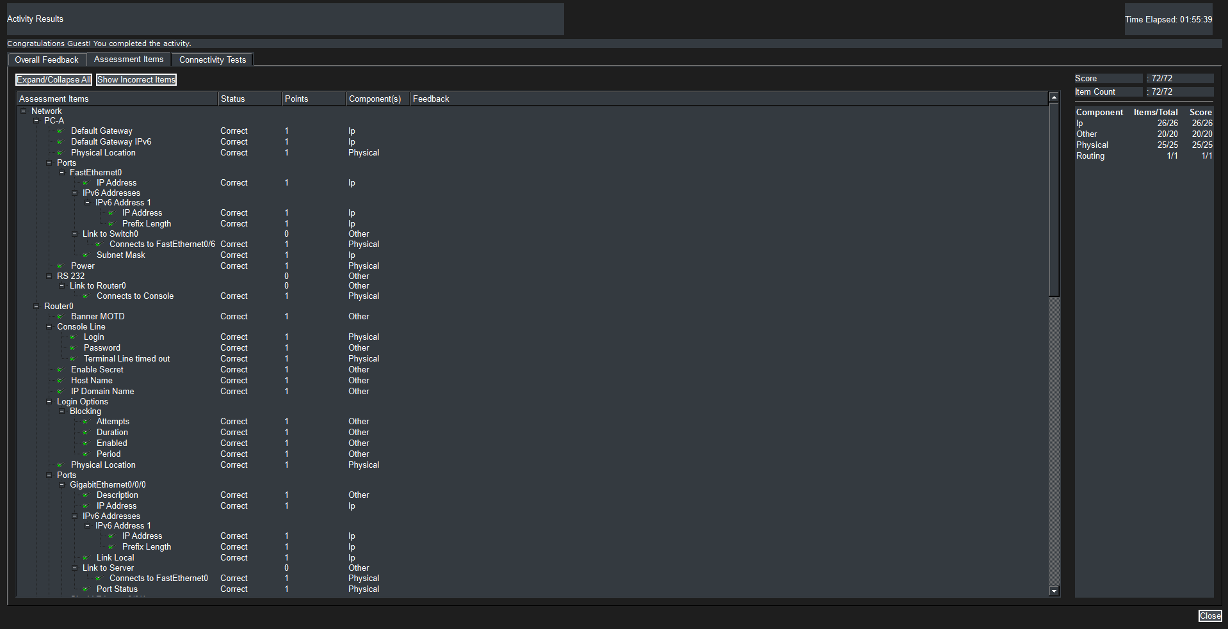
หน้าต่าง CLI ยืนยันสถานะการทำงานผ่านคำสั่งตรวจสอบระบบ เช่น show ip interface brief ซึ่งแสดงสถานะอินเตอร์เฟสเป็น Status: up และ Protocol: up ทั้ง Layer 1 และ Layer 2 บ่งบอกว่าอุปกรณ์ทำงานสัมพันธ์กันอย่างสมบูรณ์
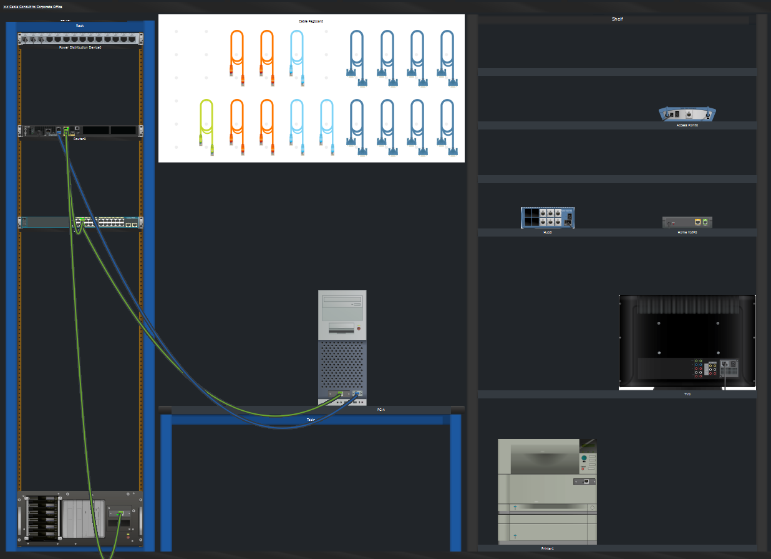
ภาพรวมของตู้ Network Rack, แผงกระจายสาย Patch Panel, การจัดสาย Rollover Console Cable สีฟ้าจากพอร์ต RS-232 บน PC เข้าสู่พอร์ต Console ของ R1 และสาย LAN ที่เชื่อมโยงเข้าสู่เครือข่ายย่อยทางกายภาพ

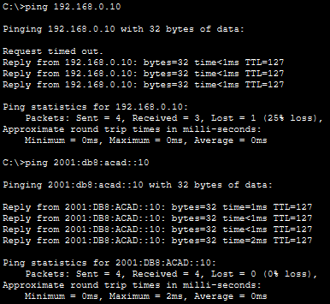
แสดงแถบความสำเร็จ Completion: 100% ใน Packet Tracer พร้อมทั้งแสดงผลลัพธ์การ Ping ทดสอบความเชื่อมต่อจาก PC-A ไปยังเซิร์ฟเวอร์ปลายทางผ่านโปรโตคอล IPv4 และ IPv6 ที่มีอัตราความสำเร็จเต็ม 100% (0% loss) รวมถึงการล็อกอินเข้าใช้งาน R1 ผ่านระบบ SSH ที่ปลอดภัยสำเร็จ

นางสาวสุชานาฏ แก้วมุงคุณ 643020651-7 sec2

